5a) Installation of KVM and creation of Virtual instances

Aim:
To install a KVM and creation of virtual instance for setting up a virtualized environment on linux system.
What is KVM?
KVM (Kernel-based Virtual Machine) is an open-source virtualization technology built into the Linux kernel. It turns Linux into a type-1 hypervisor that allows you to run multiple virtual machines (VMs) on a physical host.
Each VM has its own virtual hardware (CPU, RAM, disk, etc.), and runs its own full-fledged operating system.
Benefits of KVM
Feature | Benefit
Open Source | Free and supported by the Linux community.
Performance | Near-native performance using hardware virtualization (Intel VT or AMD-V).
Security | Isolation between VMs using SELinux and AppArmor.
Scalability | Can handle many VMs on a single host (scales well vertically).
Flexibility | Supports many OSes (Linux, Windows, BSD, etc.).
Integration | Works with tools like libvirt, virt-manager, OpenStack, etc.
Live Migration | Supports live VM migration between hosts.
Procedure:
Virtualization Technology
- Check Hardware Virtualization Support.
Output ≥ 1 indicates support. If 0, CPU doesn't support hardware virtualization.
- Run uname -a , which shows kernel name, hostname, kernel version, build date, architecture, and OS type in one line.
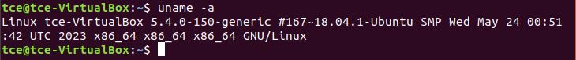
- To list the KVM kernel module files present in your kernel, run:
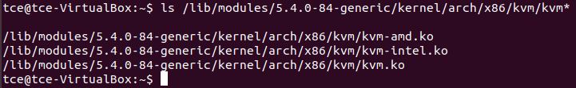

KVM Installation
- Install required packages : qemu-kvm, libvirt-bin, bridge-utils, virt-manager and qemu-system.
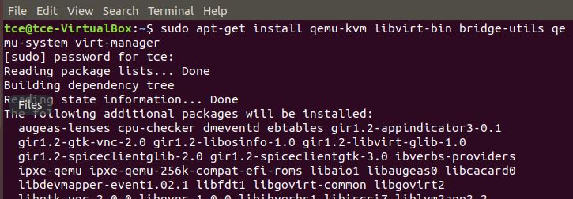
- Configure the libvirt daemon configuration file for remote access & socket permissions in KVM/libvirt
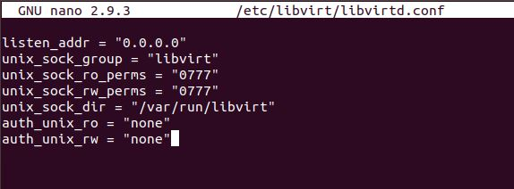

After configuring it, restart libvirtd dervice.
- Run virsh list - Displays no of Virtual machine running.
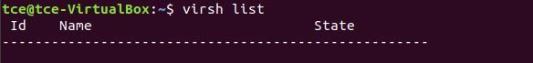
- Connecting to Virtualization interactive terminal.
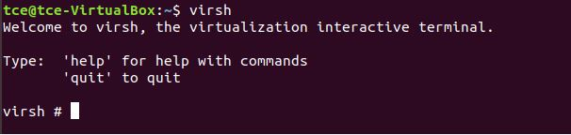
- Getting Version of libvirt & QEMU.
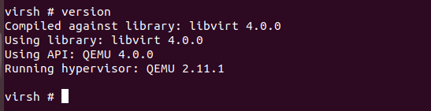
- Getting Node information
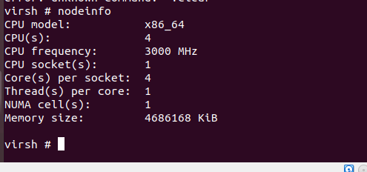
Importing existing VM
- Go to virtual machine manager (virt-manager) in your linux system. Then, right click QEMU/KVM and select New to create new VM.
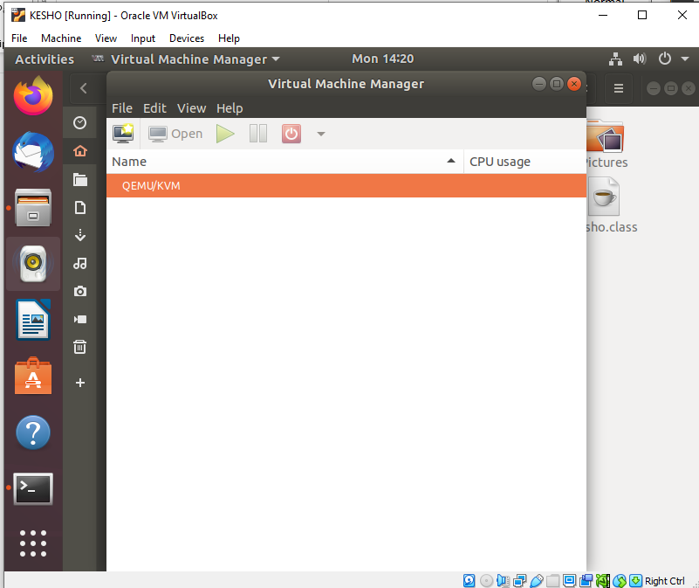

- Select import existing disk image and click forward.

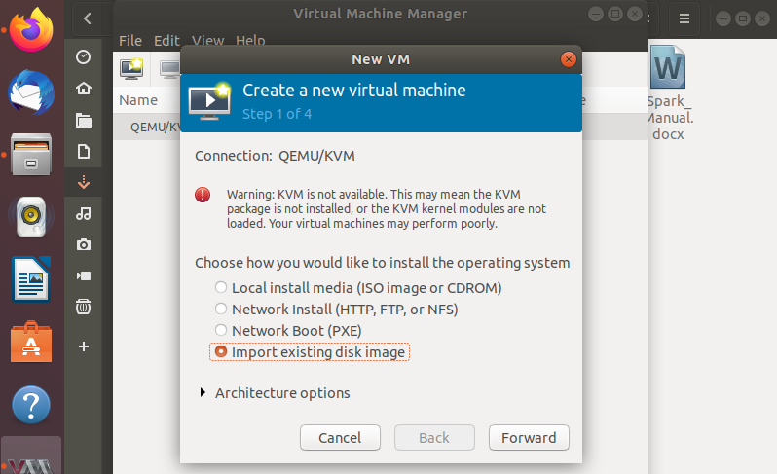

- Download cirros disk image from the link: https://download.cirros-cloud.net/0.5.1/
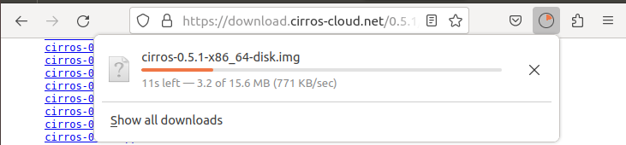
4.Give the path of downloaded cirros disk image and click forward.
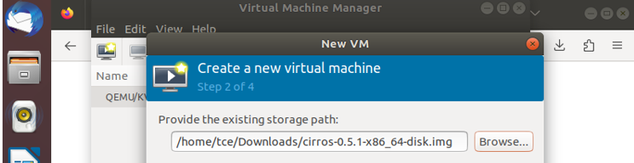

5. Choose memory and CPU settings and click forward.
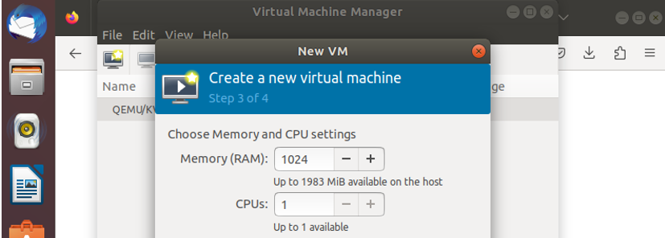
6.Name your VM and click Finish.
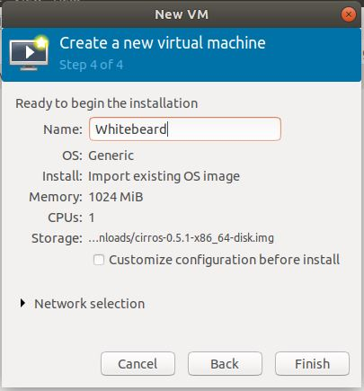

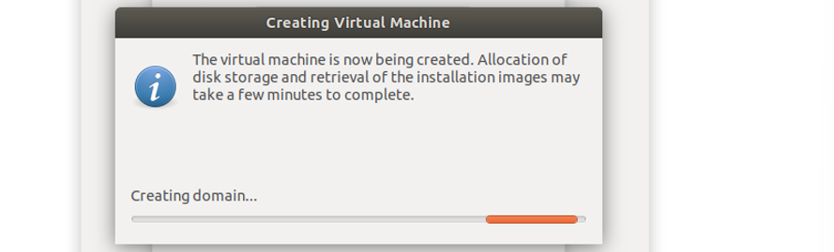

7.The VM is booted successfully and the login was also successful.
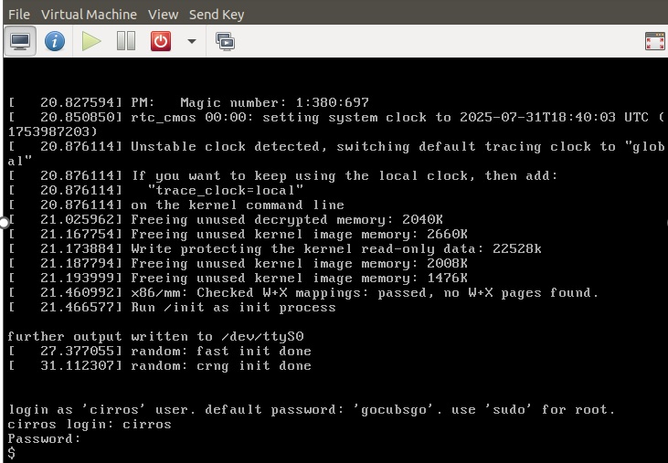

Result:
Thus, the KVM was successfully installed on the Linux system, and virtual instances were created and configured using Virt-Manager, demonstrating the setup of a virtualized environment.

5b) KVM – Create Images from ISO, Image Resizing, and Image Conversion

Aim:
To understand and demonstrate how to create virtual machine images using ISO files, resize virtual disk images, and convert disk images between various formats.

Procedure:
Creating VM image from ISO
- Go to virtual machine manager (virt-manager) in your linux system. Then, right click QEMU/KVM and select New to create new VM.

- Select Local install media (ISO image or CDOM).

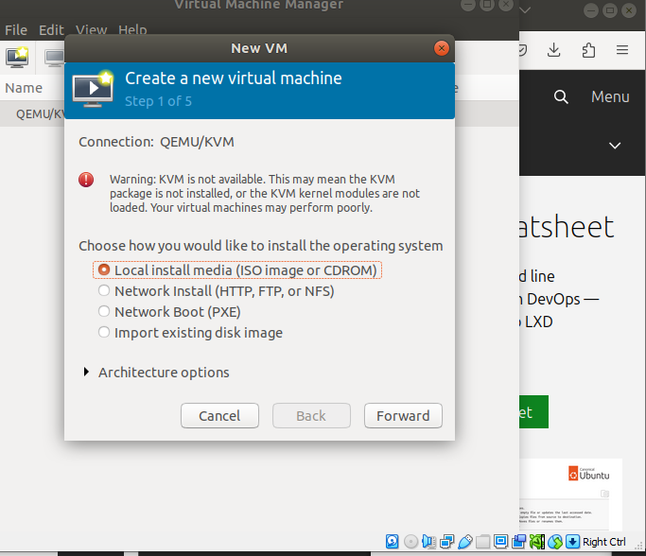

- Download ubuntu server iso from the link: https://releases.ubuntu.com/16.04/
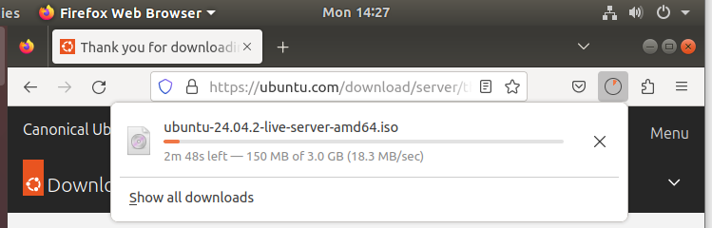

4.Select the downloaded ubuntu server iso path and click Forward.

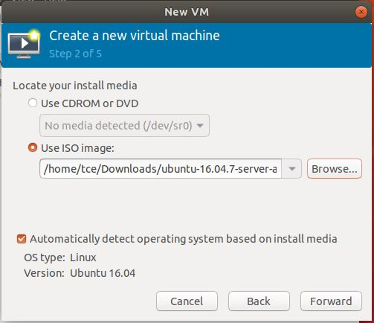

5.Specify the memory and CPU required and click Forward.

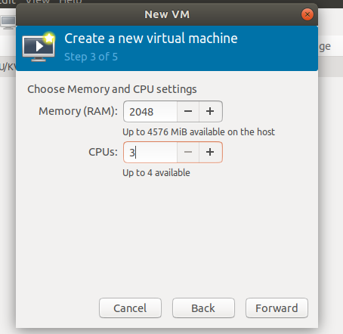

6.Run the command : qemu-img create -f qcow2 ubuntu_vm.qcow2 10G

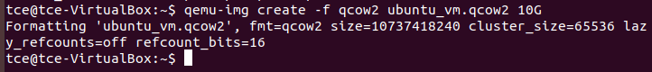
This command creates a virtual hard disk file (ubuntu_vm.qcow2) in the QCOW2 format, with a maximum size of 10 GB. This file will act as the virtual disk for a KVM virtual machine.

7.Name the VM and click Finish.

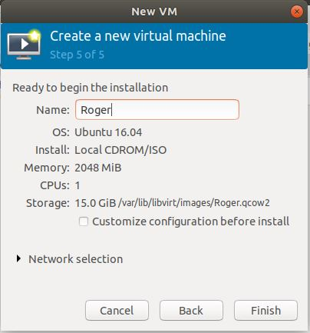
8.Select the language.

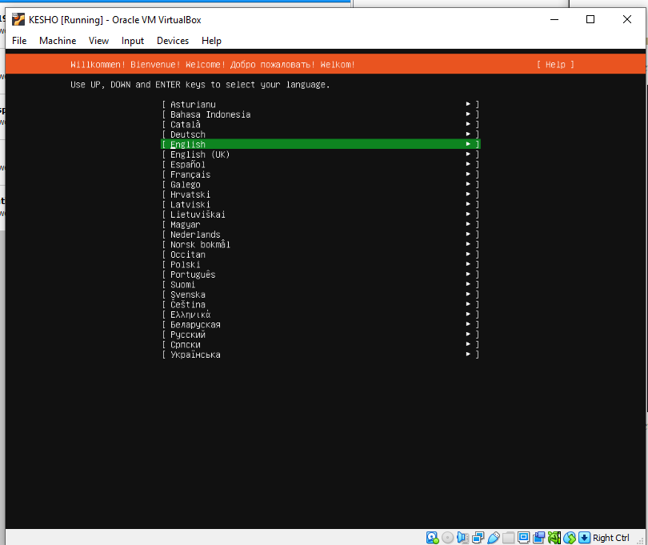

9.Select Install Ubuntu Server and then the VM boots.
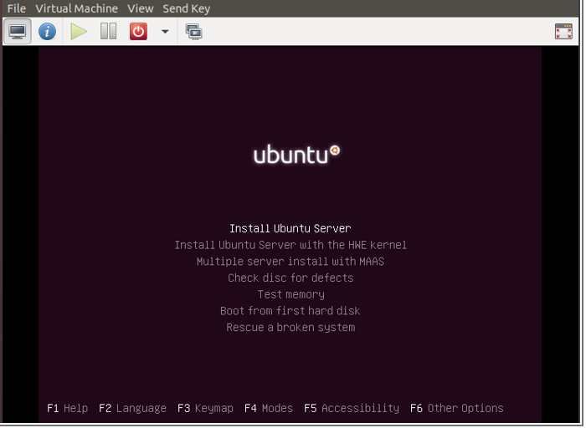

10. Select the language and location.
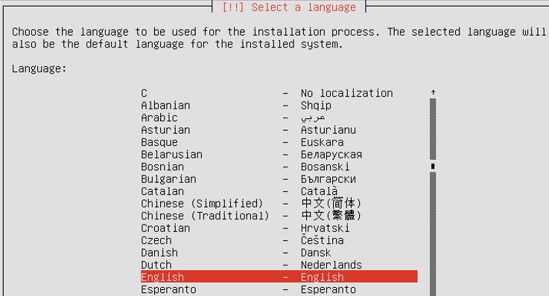
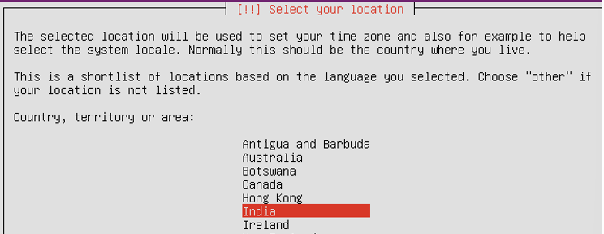

11.Set the Keyboard configuration.

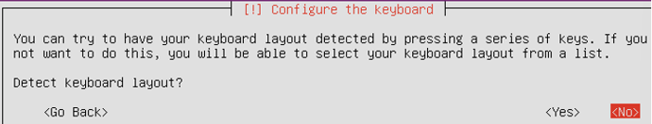
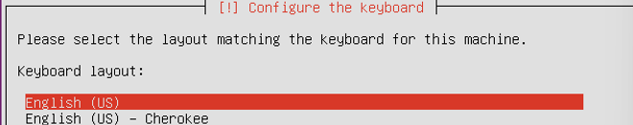
12.Then it starts detecting, loading and scanning of needed things.

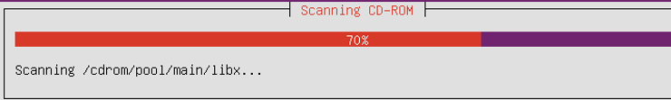
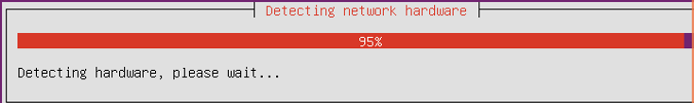
13.Then set hostname, username, password and clock settings.

14.Set the disk partition.
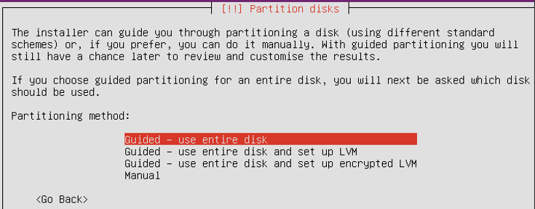
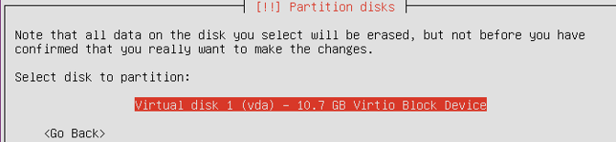
15.Select Yes to write the changes to disks.
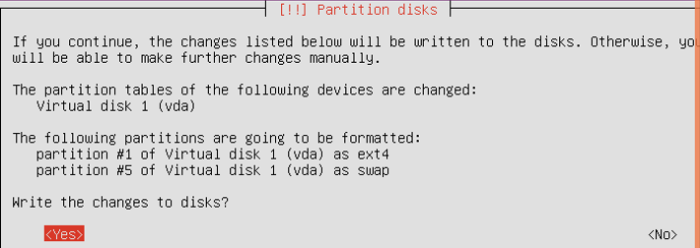
16.Then, the system installation starts.

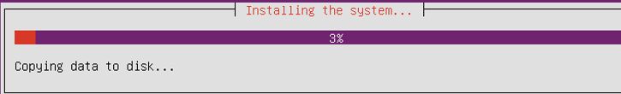
17.For http proxy, just click Enter.
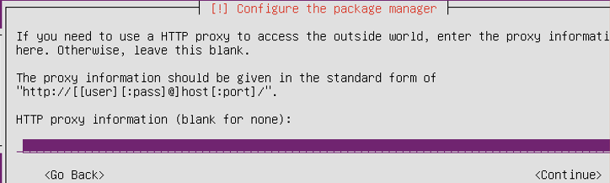
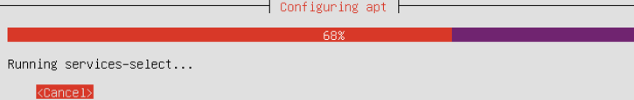
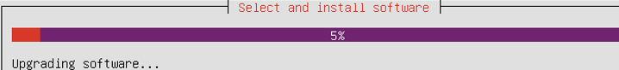

18.Select No automatic updates option for configuring tasksel.

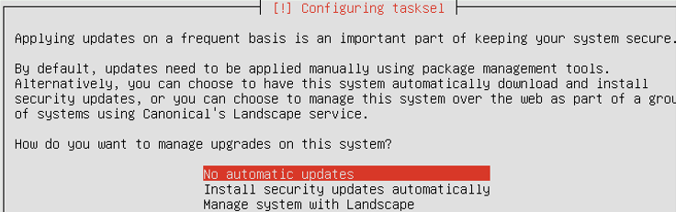
19. In Software selection, select(use Spacebar) standard system utilities and OpenSSH server.
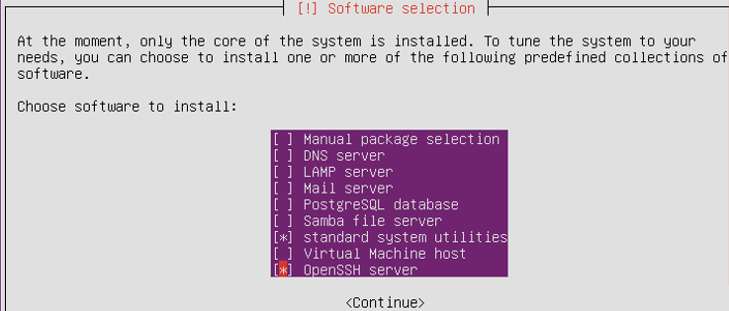

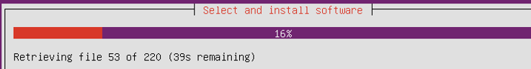
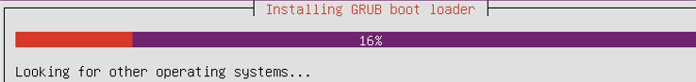
20.Give Yes to install GRUB boot loader.

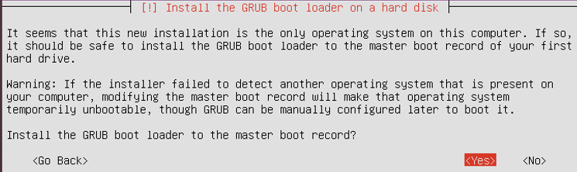
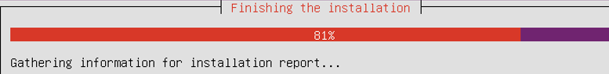
21.Now, login to your VM.
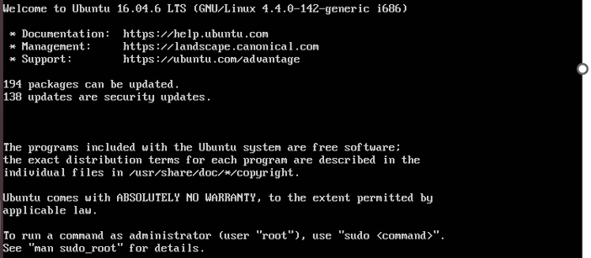
Image Resizing
- Shut down the VM if it's running.
- Resize the qcow2 image.
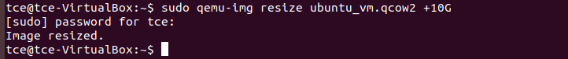
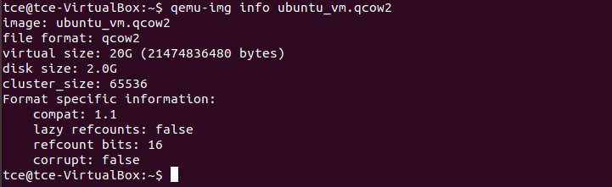
- Resize partitions inside the VM.
Once you've resized the image, boot into the VM and resize the partition/filesystem:
sudo growpart /dev/sda 1
sudo resize2fs /dev/sda1

Image Conversion
- Conversion of qcow2 to vhd, vdi using qemu-img.
qcow2 to vdi
qcow2 to vhd
qcow2 to img
Result:
Thus, the creation, resizing, and format conversion of a KVM virtual disk image were successfully demonstrated.

